The software structure

The simple calculate is the app developed by oriented-object development technology and event driving.

it has two classes .

1. class CalculatorOane:

This is calculator panel ---user interface.

it layout as follows

left : the panel on computer. right: the panel on android phone

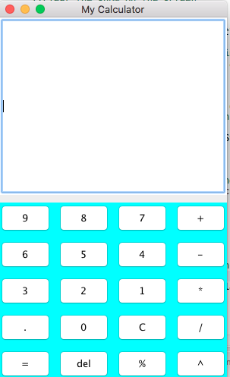

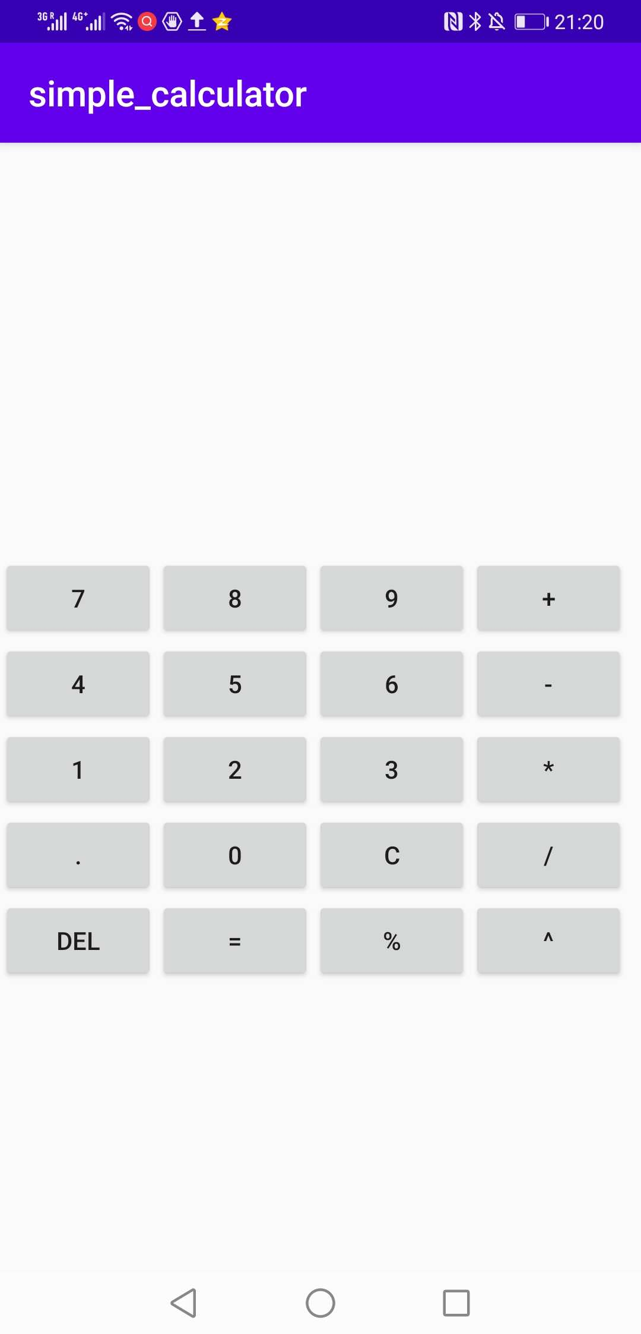

l

both contains one textField and 20 function keys

2. Class Function

The class function processes all events occurred on panel.

UML class diagram below in umple online

